The title of the article should succinctly encapsulate the content of the entire paper in a clear, definitive, and concise language structure (Time New Roman, 13pt, Bold)
Author^{1,2}, Author¹*, Author²
¹Address........., Ha Noi, Viet Nam
²Address ......., Ha Noi, Viet Nam
Corresponding Author Email: xxxxxx@gmail.com

Abstract (Time New Roman, 10pt, Bold, Italic): This section summarizes the article's content and presents the research project's key features. The summary should be presented concisely but still contain sufficient core information, with a length of about 300 words and a maximum of no more than 500 words. Typically, a good summary will be around 200-300 words. .... (Time New Roman, 10pt, Italic).
Note: Authors should also fill in information about their (Open Researcher and Contributor ID) if available in the author's full name section of the article above as in the following example: "Author¹*, Author^{2,3}".
Keywords (Time New Roman, 10pt, Bold, Italic): GIS, climate change, GNSS. (Time New Roman, 10pt, Bold, Italic)
Submission received: 15/02/2026 | Revised: 03/04/2026 | Accepted: 10/04/2026 | Published: 30/10/2025
1. Introduction (Times New Roman, 12pt, Bold)
(Times New Roman, 12pt) The guidelines in this document provide authors with detailed instructions to prepare manuscripts for the Magazine of Geodesy – Cartography . Authors should use this document as a "template" when preparing their manuscript for publication on the magazine. A good introduction should be relatively concise, explaining why readers should pay attention to the article, why the authors conducted the study, and providing necessary background for readers to understand and evaluate the paper.
2. Research Methodology (Times New Roman, 12pt, Bold)
(Times New Roman, 12pt) As the second main section of the manuscript, it typically answers in detail the question: “What did you do to answer your research question?”, in other words, presenting the methodology implemented to obtain the research results. This section serves as the foundation of a scientific paper; journal editors and peer reviewers carefully inspect the methodology for reliability. Therefore, it must be described clearly, accurately, and in detail to ensure that other researchers can replicate the study following the described procedures.
Example: The suitability levels of criteria are based on the FAO land evaluation framework and categorized as: highly suitable (S1), moderately suitable (S2), marginally suitable (S3), and not suitable (N) [1].
The AHP method developed by Saaty [2,3] is one of the most flexible and easy-to-use MCA approaches. The application of MCA and GIS in evaluating suitability for rice-crop rotation includes the following steps:
Formulas: Equations must be numbered sequentially from the beginning to the end of the manuscript, with the equation number placed in parentheses aligned to the right margin. Equations can be formatted as follows:
$$λ_{max}=\frac{\sum_{j=1}^{n}{a_{ij}}w_{j}}{w_{i}}$$ | (1)
Use MathType or the Equation tool in MS Word to present formulas in the article.

3. Kết quả nghiên cứu và thảo luận (Time New Roman, 12pt, Bold)
3.1. Research Results (Times New Roman, 12pt, Bold, Italic)
3.1.1. Results of Land Use Dynamics (Times New Roman, 12pt, Italic)
(Times New Roman, 12pt) This is the core section of the paper. The simplest approach is to present results corresponding to the sequence of objectives stated in the introduction. The results section includes data tables, figures, and charts describing the main findings of the study (do not present all raw data obtained during research). This section presents only research findings without discussion or interpretation (unless results and discussion are combined into a single section).
Images: Color images are accepted, but authors must ensure they remain legible when printed in grayscale. In the online version, figures will appear in color. Images must have a resolution of 300 dpi, with figure captions in 10pt italic font. When referencing, specify the figure number, e.g., ... as shown in Figure 1.
Note regarding geographical locations: If maps of Vietnam are included, authors must clearly display and denote islands and archipelagos under Vietnamese sovereignty, such as Truong Sa (Spratly) Archipelago, Hoang Sa (Paracel) Archipelago, Phu Quoc, Tho Chu, etc., in accordance with national regulations.
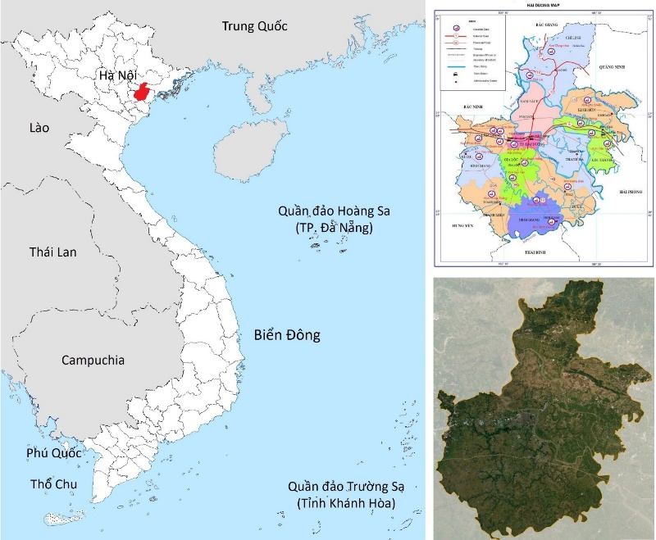
Figure 1. Study area (Caption in Italic, fontsize 10, centered)
Tables: Tables should be presented as shown in Table 1, 10pt font, with a bold header row. The table title should be in italics, 10pt font, left-aligned.
Table 1. Example table (Italic, fontsize 10, left-aligned)
Column 1 (Bold, 10pt | |Column 2 | Column 3 | Column 4 | Column n
Value 1 (fontsize 10) | 14884 | 14884 | 32 | 32
Value 2 | 3842 | 3842 | 8 | 8
Value n | 21338 | 21338 | 45 | 45
Total | ..... | ..... | ..... | .....

3.2. Discussion (Times New Roman, 12pt, Bold, Italic)
(Times New Roman, 12pt) This is the final part of the main body of the research paper that interprets research results, specifically:
Explaining the significance of collected results
Clearly answering research questions or hypotheses raised in the introduction
Discussing study limitations and their potential impacts on results
Clarifying how results relate to similar studies conducted previously
Suggesting implications of research for researchers, practical professionals, or policy makers
Recommending topics for future research based on achieved results
4. Conclusion (Times New Roman, 12pt, Bold)
(Times New Roman, 12pt) In this section, the author summarizes and reaffirms the main research findings and key discoveries to answer the questions posed in the introduction. What was set out in the objectives must have specific answers in the conclusion, supported by scientific evidence shown in the results section. However, conclusions should be concise, avoiding repeating all details from the results section. At the end of this section, authors may provide recommendations that closely align with the conclusions. Recommendations should specify target audiences and concrete measures, avoiding generic recommendations not based on specific findings.
Upon receiving the manuscript, the Editorial Board will conduct an initial check on content and formatting. If compliant with guidelines, it will be sent for peer review. After review, if revisions are required, the manuscript will be sent back to the corresponding author. Authors should respond point-by-point to reviewer comments and suggestions regarding revisions or retentions.

Acknowledgements (Times New Roman, 12pt, Bold)
(Times New Roman, 12pt) Authors should express gratitude to agencies and organizations that funded the research, provided support, or supplied research data.

Authors' Commitment (Times New Roman, 12pt, Bold)
(Times New Roman, 12pt) All named authors confirm their consensus and declare no conflicts of interest regarding the scientific publication of this manuscript.
References (Times New Roman, 10pt, Bold)
References must be numbered sequentially in order of citation in the text, starting from [1] to the end. The reference list must contain complete details for all cited publications. Only cited publications should be listed. References should consist of high-quality and recent publications. The manuscript formatting and EndNote citation style follow the IEEE format (`GeocartaGIS.ens`), which can be downloaded at:
https://geocartagis.vn/geocartagis/en/libraryFiles/downloadPublic/10
Sample list of references (Times New Roman, 10pt):
- Lại Vĩnh Cẩm, “Luận cứ phục vụ định hướng phát triển kinh tế - xã hội khu vực miền tây tỉnh Quảng Bình”, Sở khoa học và công nghệ Quảng Bình, trang 261-269, 2004.
- Lê Cảnh Định, “Tích hợp phần mềm ALES và GIS trong đánh giá đất đai”, Luận văn thạc sĩ. Trường ĐH Bách khoa TP.HCM, 2004.
- Nguyễn Kim Lợi, Lê Tiến Dũng, “Ứng dụng GIS phục vụ quy hoạch sử dụng đất tại huyện Xuân Lộc, tỉnh Đồng Nai”, Kỷ yếu hội thảo ứng dụng GIS toàn quốc, trang 21-29, 2009.
- Alejandro Ceballos Silva, Jorge Lopez Blanco, “Delineation of suitable areas for crops using a Multi - Criteria Evaluation approach and landuse/cover mapping: a case study in Central Mexico”, Agricultural Systems vol. 77, no. 1, pp.117 – 136, 2003. https://doi.org/10.1016/S0308-521X(02)00103-8
- Anatoly Gitelson, Mark Merzlyak, and Olga Chivkunova, “Optical properties and nondestructive estimation of anthocyanin content in plant leaves”, Photochemistry photobiology, vol. 74, no. 1, pp. 38-45, 2001. https://doi.org/10.1562/0031-8655(2001)0740038OPANEO2.0.CO2
- Đặng Thanh Tùng và cộng sự, “Phương pháp phân loại lớp phủ bề mặt sử dụng ảnh cường độ phản hồi từ dữ liệu Lidar kết hợp với ảnh viễn thám”, Tạp chí khoa học đo đạc và bản đồ - Journal of Geodesy and Catography, số. 12, trang. 29-36, 2012. https://doi.org/10.54491/jgac.2012.12.489
Article © 2026 by Magazine of Geodesy - Cartography is licensed under CC BY 4.0 | 

